**Midterm 2**

Jiaqi Li

1.1

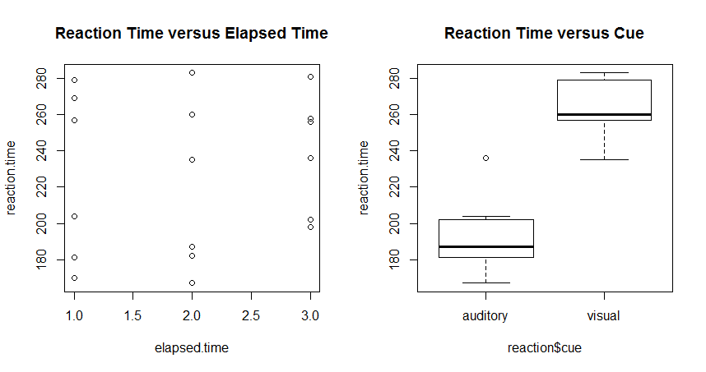

1.2

First, we want to set up the 2-way complete model:

Yijt = μ + αi + βj + (αβ)ij + ϵijt, ϵijt ∼ N(0,σ2) with iid

Yijt = the reaction time with ith cue and jth elapsed time.

i = auditory, visual j = 1, 2, 3

> lsm.reaction=aov(reaction.time~cue+elapsed.time+cue:elapsed.time,data=reaction)

> par(mfrow=c(2,2))

> plot(lsm.reaction)

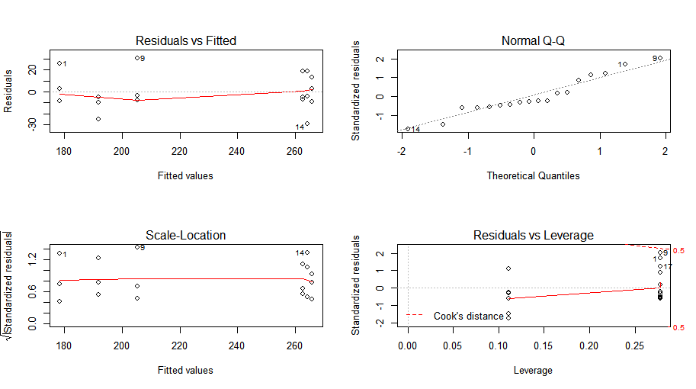

The plots show that the residuals of the 2-way complete model satisfy constant variance and the Q-Q plot shows the normality. Thus, assumptions are satisfied. No transformation is needed at this time. We can do further study with this model.

|  |
| --- |
| > anova(lsm.reaction)  Analysis of Variance Table  Response: reaction.time  Df Sum Sq Mean Sq F value Pr(>F)  cue 1 23544.5 23544.5 75.4929 5.17e-07 ***  elapsed.time 1 420.1 420.1 1.3470 0.2652  cue:elapsed.time 1 690.1 690.1 2.2127 0.1591  Residuals 14 4366.3 311.9  ---  Signif. codes: 0 ‘***’ 0.001 ‘**’ 0.01 ‘*’ 0.05 ‘.’ 0.1 ‘ ’ 1 |

**For Interaction term**:

H0: combination of cue and elapsed time has no impact on the mean reaction time

Test Statistic F1,14 = 2.2127

p-value = 0.1591 > α = 0.05

Since the p-value of the interaction term is larger than 0.05, we fail to reject null hypothesis and conclude that different combinations of cue and elapsed time have no impact on mean reaction time.

**For Cue**:

H0: cue has no impact on reaction time

Test Statistic F1,14 = 75.4929

p-value = 5.17 × 10-7 < α = 0.05

Since the p-value of the cue is smaller than 0.05, we reject null hypothesis and conclude that different cues have impacts on mean reaction time.

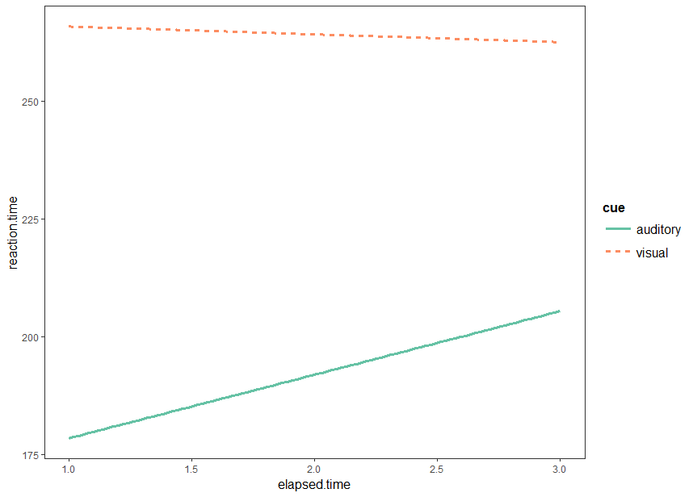

|  |
| --- |
| > contrast(reaction.cue, method="pairwise")  contrast estimate SE df t.ratio p.value  auditory - visual -72.33333 8.325022 14 -8.689 <.0001 |

By observing the chart above, we can see that the visual cue has more impacts on the mean reaction time than the auditory cue has.

**For Elapsed Time**:

H0: elapsed time has no impact on reaction time

Test Statistic F1,14 = 1.3470

p-value = 0.2652 > α = 0.05

Since the p-value of the elapsed time is larger than 0.05, we fail to reject null hypothesis and conclude that different elapsed time have no impact on mean reaction time.

2.

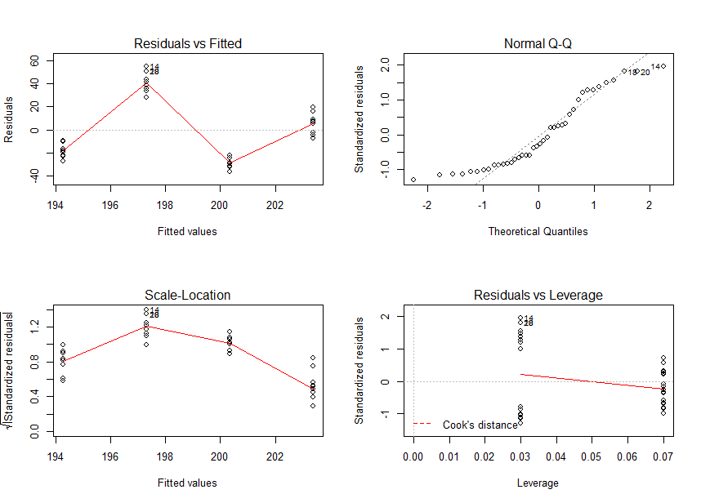

> lsm.melt.transf=aov(sin(Times)~Brand,data=melt)

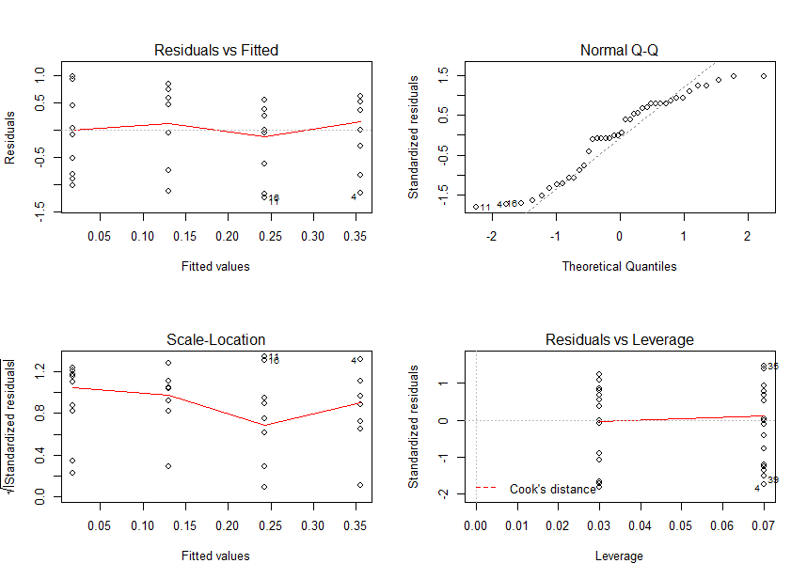

> shapiro.test(lsm.melt.transf$residuals)

Shapiro-Wilk normality test

data: lsm.melt.transf$residuals

W = 0.92654, p-value = 0.01244

3.1

This experiment is a completely randomized design because for each treatment (softwood and hardwood), 4 trees are randomly selected from a larger population of each species.

3.2

> lsm.wood=aov(Nconc~Type/Species,data=wood)

> par(mfrow=c(2,2))

> plot(lsm.wood)

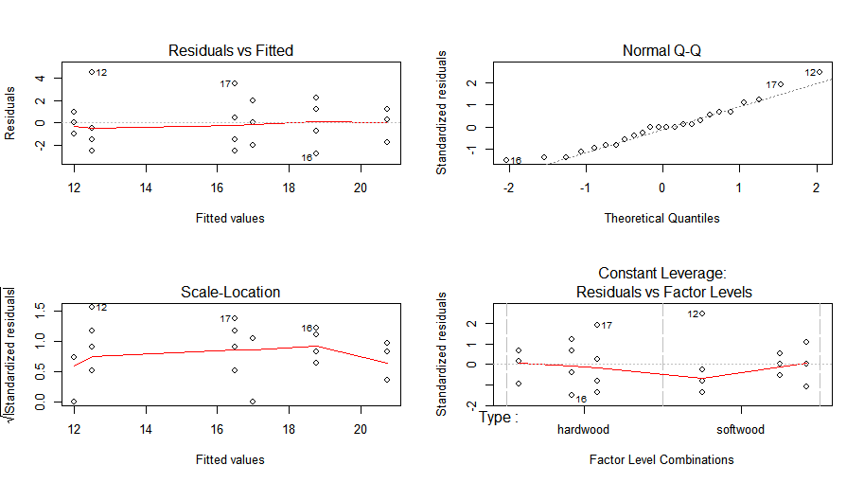

The plots show that the residuals of the 2-way nested model satisfy constant variance and the Q-Q plot shows the normality. Thus, assumptions are satisfied. No transformation is needed at this time. We can do further study with this model.

|  |
| --- |
| > anova(lsm.wood)  Analysis of Variance Table  Response: Nconc  Df Sum Sq Mean Sq F value Pr(>F)  Type 1 140.167 140.167 31.7358 2.408e-05 ***  Type:Species 4 96.833 24.208 5.4811 0.004574 **  Residuals 18 79.500 4.417  ---  Signif. codes: 0 ‘***’ 0.001 ‘**’ 0.01 ‘*’ 0.05 ‘.’ 0.1 ‘ ’ 1 |

**For Interaction term**:

H0: combination of Type and Species has no impact on the mean reaction time

Test Statistic F4,18 = 5.4811

p-value = 0.004574 < α = 0.05

Since the p-value of the interaction term is smaller than 0.05, we reject null hypothesis and conclude that different combinations of Type and Species have impact on mean nitrogen content.

Then we will do pairwise comparison:

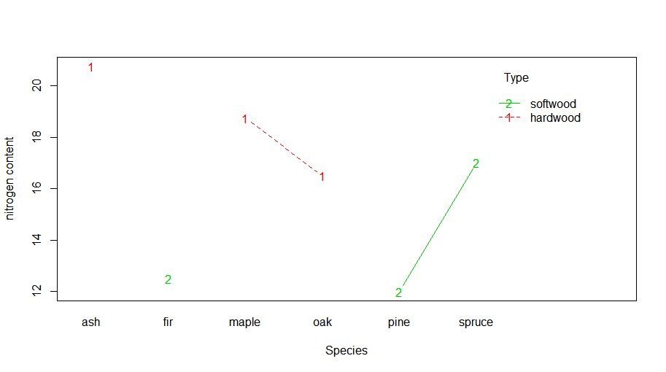

|  |
| --- |
| > contrast(wood.ST, method="pairwise")  contrast estimate SE df t.ratio p.value  ash,hardwood - maple,hardwood 2.00 1.486046 18 1.346 0.7567  ash,hardwood - oak,hardwood 4.25 1.486046 18 2.860 0.0923  ash,hardwood - fir,softwood 8.25 1.486046 18 5.552 0.0004  ash,hardwood - pine,softwood 8.75 1.486046 18 5.888 0.0002  ash,hardwood - spruce,softwood 3.75 1.486046 18 2.523 0.1689  maple,hardwood - oak,hardwood 2.25 1.486046 18 1.514 0.6602  maple,hardwood - fir,softwood 6.25 1.486046 18 4.206 0.0060  maple,hardwood - pine,softwood 6.75 1.486046 18 4.542 0.0029  maple,hardwood - spruce,softwood 1.75 1.486046 18 1.178 0.8416  oak,hardwood - fir,softwood 4.00 1.486046 18 2.692 0.1257  oak,hardwood - pine,softwood 4.50 1.486046 18 3.028 0.0670  oak,hardwood - spruce,softwood -0.50 1.486046 18 -0.336 0.9993  fir,softwood - pine,softwood 0.50 1.486046 18 0.336 0.9993  fir,softwood - spruce,softwood -4.50 1.486046 18 -3.028 0.0670  pine,softwood - spruce,softwood -5.00 1.486046 18 -3.365 0.0344  P value adjustment: tukey method for comparing a family of 6 estimates |

By observing the chart above, we can conclude that:

* Species of fir in soft wood category has less impact on mean nitrogen content than species of ash in hard wood category has.
* Species of pine in soft wood category has less impact on mean nitrogen content than species of ash in hard wood category has.
* Species of fir in soft wood category has less impact on mean nitrogen content than species of maple in hard wood category has.
* Species of pine in soft wood category has less impact on mean nitrogen content than species of maple in hard wood category has.
* Species of pine in soft wood category has more impact on mean nitrogen content than species of spruce in soft wood category has.
* No other comparisons are significantly different than zero based on the p-values.

**For Type**:

H0: Type has no impact on reaction time

Test Statistic F1,18 = 31.7358

p-value = 2.408 × 10-5 < α = 0.05

Since the p-value of the Type is smaller than 0.05, we reject null hypothesis and conclude that Type has impacts on mean nitrogen content.

|  |
| --- |
| > cld(wood.T, alpha=0.05)  Type lsmean SE df lower.CL upper.CL .group  softwood 13.83333 0.6066758 18 12.55875 15.10791 1  hardwood 18.66667 0.6066758 18 17.39209 19.94125 2  Results are averaged over the levels of: Species  Confidence level used: 0.95  significance level used: alpha = 0.05 |

By observing the chart above, we can see that soft wood has less impacts on mean nitrogen content than hard wood has.

4.1

(crocks nested in soak time, crocks crossed with recipes, response = reating, jars=reciprocals)

4.2

> lsm.tast=aov(Rating~SoakTim+Crock:SoakTim+Recipe+SoakTim:Recipe,data=beans)

> par(mfrow=c(2,2))

> plot(lsm.tast)

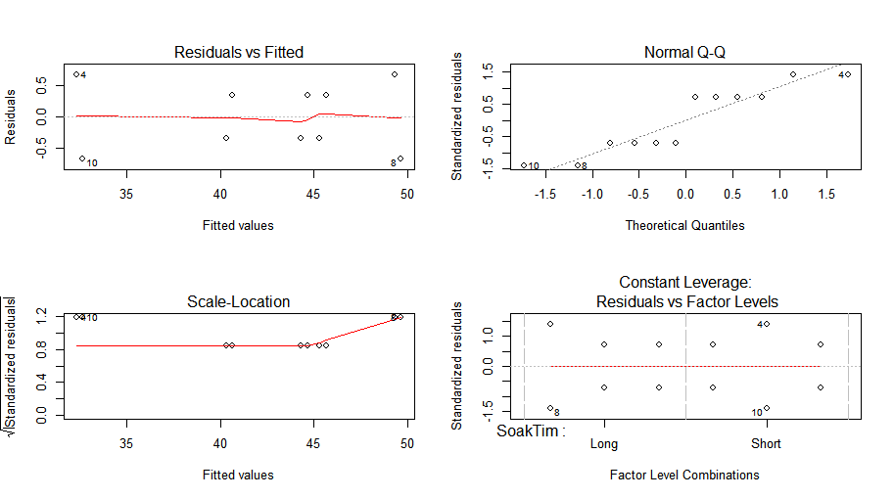

The plots show that the residuals of the mixed model satisfy constant variance and the Q-Q plot shows the normality. Thus, assumptions are satisfied. No transformation is needed at this time. We can do further study with this model.

|  |
| --- |
| > anova(lsm,tast)  Error in UseMethod("anova") :  no applicable method for 'anova' applied to an object of class "function"  > anova(lsm.tast)  Analysis of Variance Table  Response: Rating  Df Sum Sq Mean Sq F value Pr(>F)  SoakTim 1 225.333 225.333 338.00 5.15e-05 ***  Recipe 2 72.667 36.333 54.50 0.001253 **  SoakTim:Crock 2 0.333 0.167 0.25 0.790123  SoakTim:Recipe 2 40.667 20.333 30.50 0.003787 **  Residuals 4 2.667 0.667  ---  Signif. codes: 0 ‘***’ 0.001 ‘**’ 0.01 ‘*’ 0.05 ‘.’ 0.1 ‘ ’ 1 |

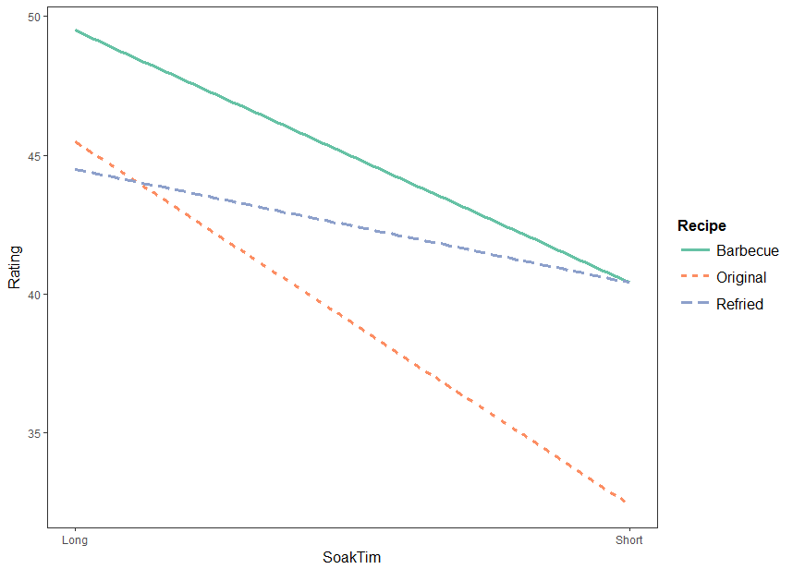

**R code:**

**#install.packages("jtools")**

**#1.data-------------------------------------------------------------------------------------------**

**cue=c(rep("auditory",9),rep("visual",9))**

**elapsed.time=rep(rep(1:3,each=3),2)**

**reaction.time=c(204,170,181,167,182,187,202,198,236,257,279,269,283,235,260,256,281,258)**

**#1.1-------------------------------------------------------------------------------------------**

**reaction=data.frame(cue=cue,elapsed.time=elapsed.time,reaction.time=reaction.time)**

**plot(reaction.time~elapsed.time,main="Reaction Time versus Elapsed Time")**

**plot(reaction.time~reaction$cue,main="Reaction Time versus Cue")**

**#1.2-------------------------------------------------------------------------------------------**

**library(lsmeans)**

**lsm.reaction=aov(reaction.time~cue+elapsed.time+cue:elapsed.time,data=reaction)**

**par(mfrow=c(2,2))**

**plot(lsm.reaction)**

**anova(lsm.reaction)**

**library(jtools)**

**interact_plot(lsm.reaction,pred="elapsed.time",modx="cue")**

**reaction.cue=lsmeans(lsm.reaction,~cue)**

**contrast(reaction.cue, method="pairwise")**

**#2-------------------------------------------------------------------------------------------**

**Brand<-c(rep(1,10), rep(2, 10), rep(3,10), rep(4, 10))**

**Times<-c(167, 171, 178, 175, 184, 176, 185, 172, 178, 178,**

**231, 233, 236, 252, 233, 225, 241, 248, 239, 248,**

**176, 168, 171, 172, 178, 176, 169, 164, 169, 171,**

**201, 199, 196, 211, 209, 223, 209, 219, 212, 210)**

**melt=data.frame(Brand,Times)**

**lsm.melt=aov(Times~Brand,data=melt)**

**par(mfrow=c(2,2))**

**plot(lsm.melt)**

**lsm.melt.transf=aov(sin(Times)~Brand,data=melt)**

**par(mfrow=c(2,2))**

**plot(lsm.melt.transf)**

**shapiro.test(lsm.melt.transf$residuals)**

**#3.2-------------------------------------------------------------------------------------------**

**wood=read.table("wood.csv",header=TRUE)**

**wood**

**#Type<-as.factor(wood$Type)**

**#Species<-as.factor(wood$Species)**

**#Nconc<-wood$Nconc**

**#df=data.frame(Type=Type,Species=Species,Nconc=Nconc)**

**options(contrasts =c("contr.sum", "contr.poly"))**

**lsm.wood=aov(Nconc~Type/Species,data=wood)**

**par(mfrow=c(2,2))**

**plot(lsm.wood)**

**anova(lsm.wood)**

**par(mfrow=c(1,1))**

**interaction.plot(x.factor = wood$Species, trace.factor = wood$Type, response = wood$Nconc,**

**type ="b",col = 2:3,xlab ="Species", ylab ="nitrogen content", trace.label ="Type")**

**library(multcompView)**

**wood.ST=lsmeans(lsm.wood, ~Species:Type)**

**contrast(wood.ST, method="pairwise")**

**#cld(wood.ST, alpha=0.05)**

**wood.T=lsmeans(lsm.wood, ~Type)**

**cld(wood.T, alpha=0.05)**

**#4.2-------------------------------------------------------------------------------------------**

**beans=read.table("Beans.csv",header=TRUE)**

**beans**

**lsm.tast=aov(Rating~SoakTim+Crock:SoakTim+Recipe+SoakTim:Recipe,data=beans)**

**par(mfrow=c(2,2))**

**plot(lsm.tast)**

**anova(lsm.tast)**

**interact_plot(lsm.tast,pred="SoakTim",modx="Recipe")**